Bluetooth Beacon Guide

# 1. Summary

The Bluetooth beacon is installed at a Producers location, and is used to verify the location of the producer. A Producer must connect to the beacon and download a secret code, that will be sent to the ProductChain servers to confirm that the Producer is legitimate.

# 2. Requirements

* Android 4.0 or newer
* Application size: 2.01MB
* Phone must have Bluetooth
* Beacon must contain required keys.

## 2.1 Permissions

* android.permission.BLUETOOTH
* android.permission.BLUETOOTH_ADMIN
* android.permission.ACCESS_COARSE_LOCATION

# 3. Installation guide

1. Open the Bluetooth Beacon project in Android Studio

2. Change the commons-codec-1.10.jar build path in build.gradle to the include/commons-codec-1.10.jar file.

3. Generate a keypair for each new Producer as per ‘*Generating Keys Guide’.*

4. Copy **all four** generated keys for each Producer into the assets folder of the Bluetooth beacon project.

5. Run the application to install it to the Android Device.

# 4. Display Sequence

**Note**: The Bluetooth beacon and the Android device running the Producer Application will need to pair Bluetooth before this section of the application can be used.

Step 1. Open the application. The console will appear and notify you that the Bluetooth beacon has been turned on. The current producer will be displayed in the lower left corner of the screen.

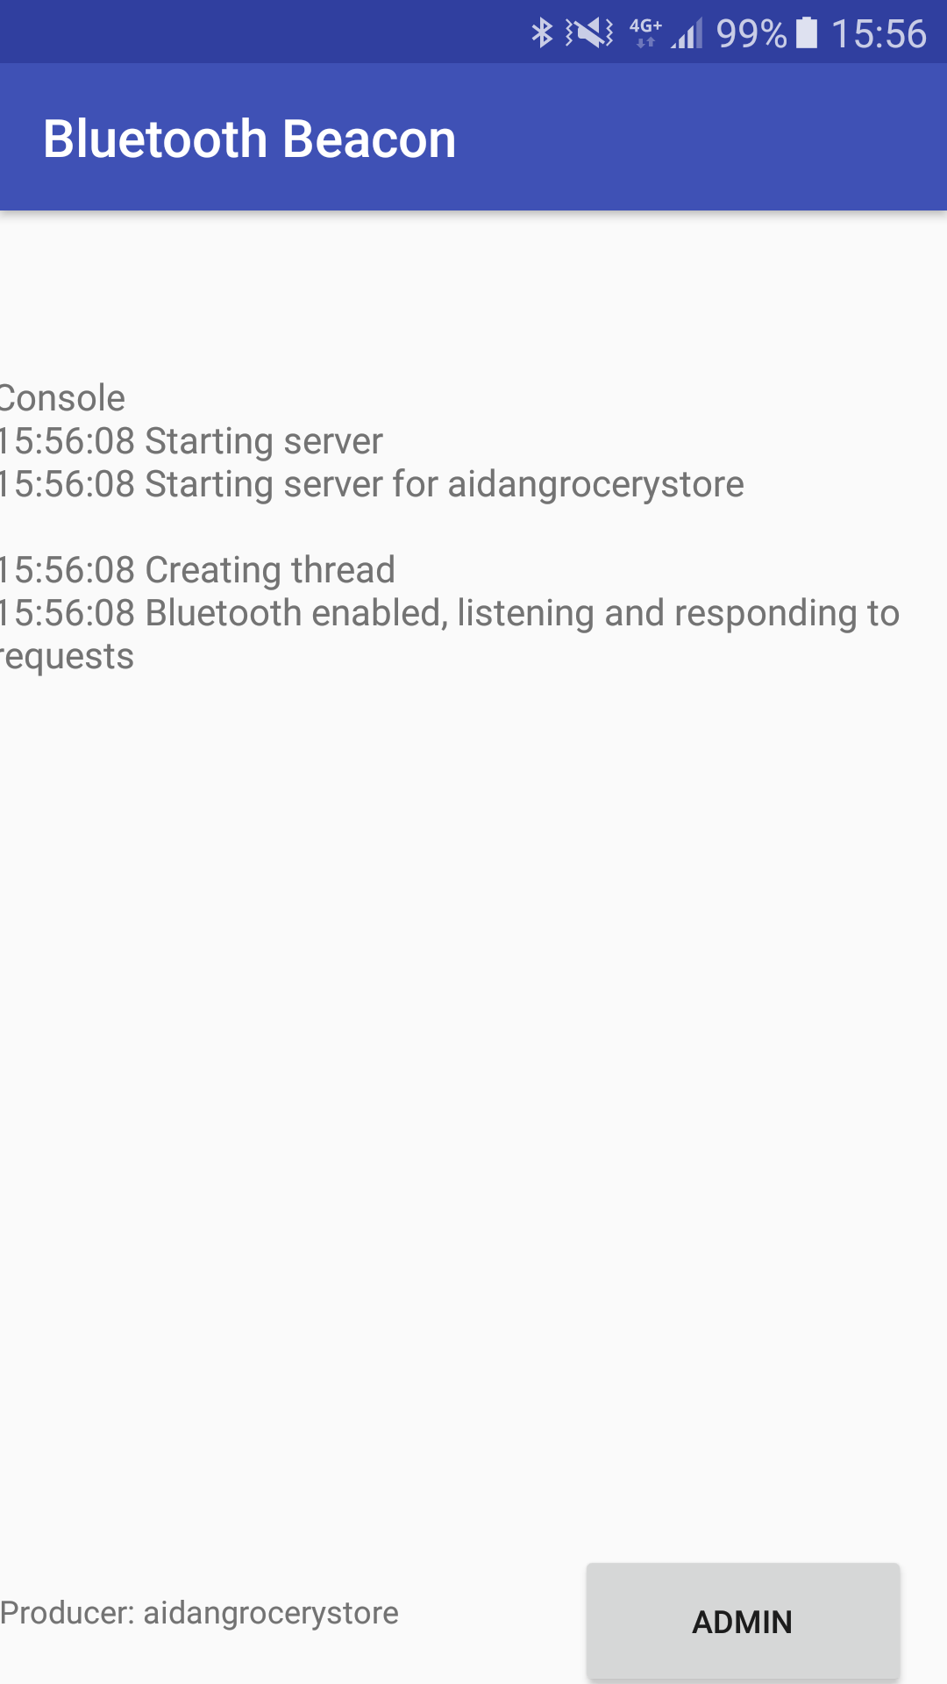

Step 2. For testing purposes, an Admin page has been setup. This allows a user to test different test producers before rolling out the device. If a new producer is selected, they will appear at the bottom left corner of the screen on the main page.

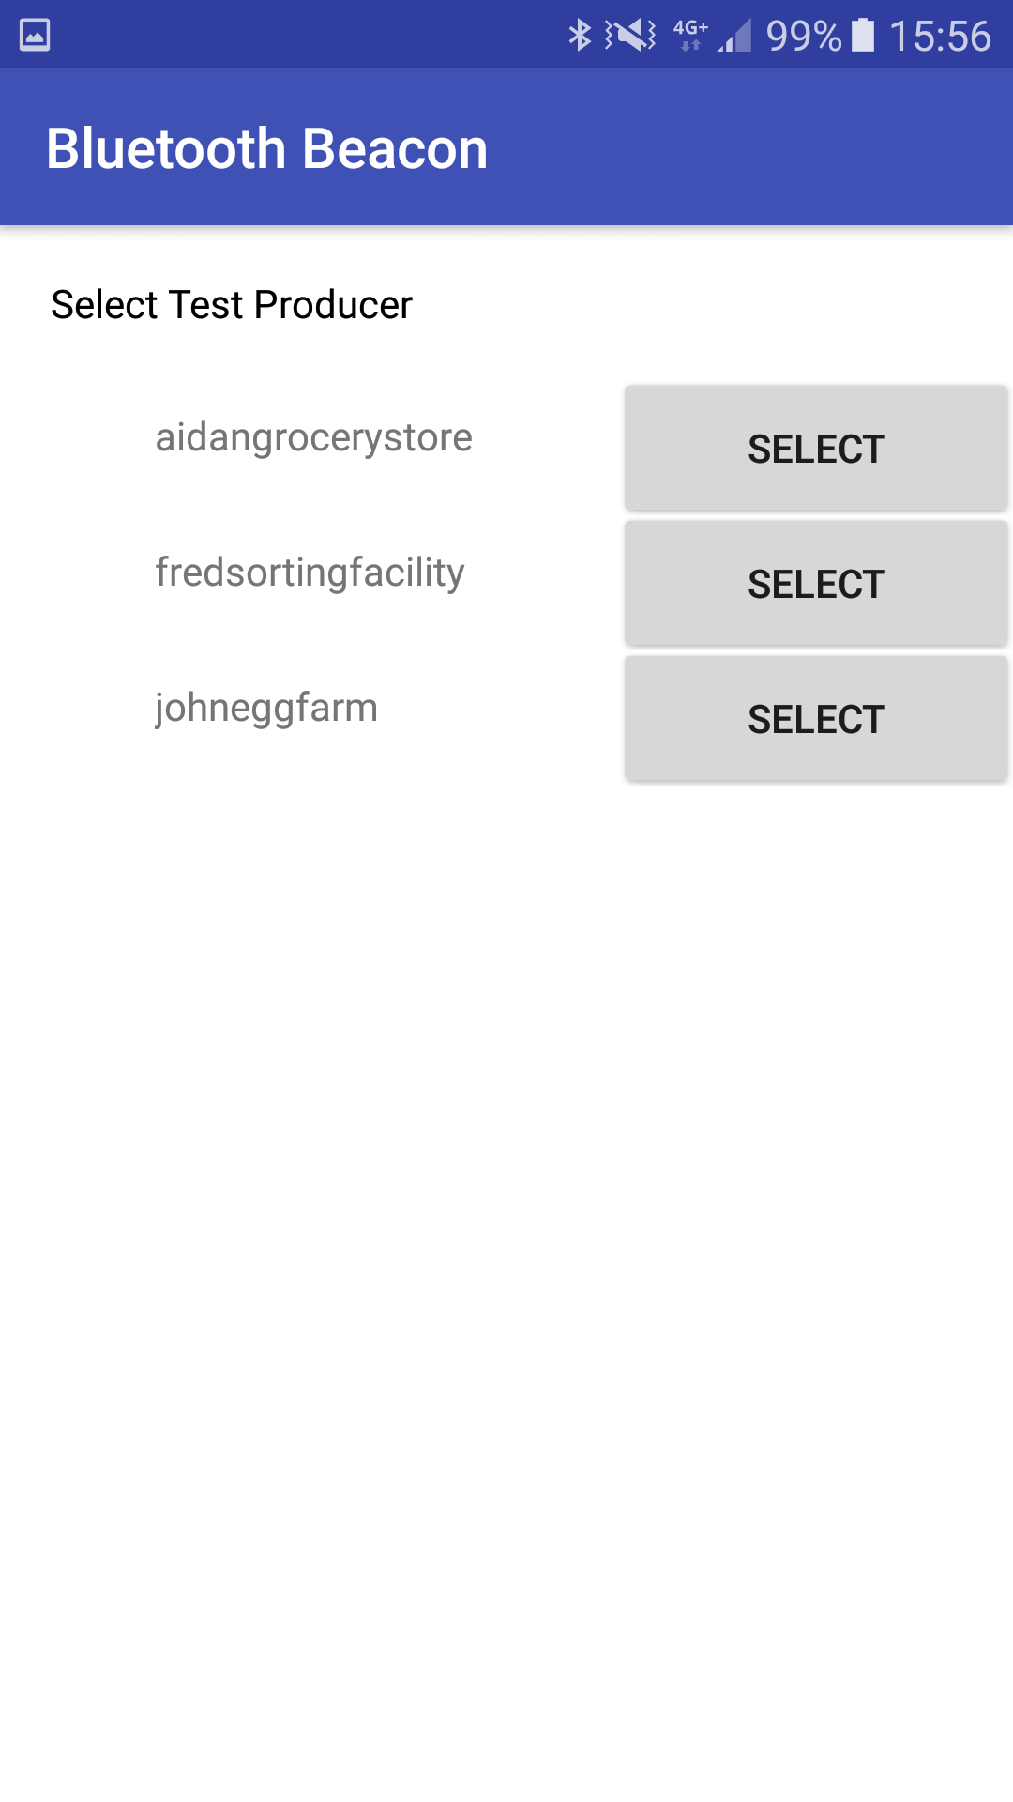

# 5. Known Bugs

1. If a producer is changed, the console will not update when a Producer connects to it. All functionality still works however, and the beacon will still validate producers.